

Table of Contents

**Introduction 1**

**Top 15 Reasons We Must Learn To Face And Deal With Life Challenges 3**

**There Will ALWAYS Be Challenges In Life 3**

**Challenges Help You Develop Perspective 3**

**Facing Challenges Helps You Become Stronger 4**

**Challenges Nurture Your Mind 4**

**Challenges Build Your Emotional Reserves 4**

**Facing Challenges Extends Your Comfort Zone 5**

**Ignoring Challenges Just Makes Them Come Back Again And Again 5**

**Challenges Can Reveal Powers You Didn’t Know You Had 5**

**Challenges Are How We Change 6**

**Through Challenge, We Connect With Others 6**

**Challenges Are Opportunities 6**

**Challenges Prove That You Are Taking Risks 6**

**Challenges Teach Us That Nothing Is Impossible 7**

**Become A Better Problem Solver 7**

**Gain Satisfaction From Your Accomplishments 7**

**The Only Control We Have Is How We Deal With Challenges 8**

**Top Life Challenges And How To Overcome Them 9**

**Dealing with Change 9**

**Life Unfairness 11**

**Job Loss/Career Challenges 11**

**Heartbreak and Failed Relationships 13**

**Financial Crisis 14**

**Major Disappointments 16**

**Dealing with Your Reality Just as It Is 17**

**Living Life on Life’s Terms 18**

**Living in The Past or Future 19**

**Family Issues 20**

**Fear 21**

**Failure 22**

**Learning Proper Methods of Self Care 22**

**Health Problems 23**

**Discontentment or Lack of Fulfillment 24**

**Lack of Motivation 26**

**Unhappiness 27**

**The Reality of Aging 28**

**Grief and Loss 29**

**Criticism from Others 31**

**Dealing with Difficult People 33**

**Existential Crisis of Struggling with Self-Identity 34**

**Understanding What Is Important in Life 36**

**The Illusion of Control 38**

**10 Inner Traits You Need to Overcome Any Challenge You May Face 40**

**Proper Mindset To Face Life Challenges 43**

**The Role of Positive Thinking in Facing Life Challenges 43**

**The Role Of Perseverance In Facing Life Challenges 44**

**The Role Of Resilience In Facing Life Challenges 45**

**Winners Never Quit: Dealing With The Life Challenge Of Failure 46**

**Preventable Life Challenges: The Role Of Planning 49**

**Final Thoughts 51**

**Disclaimer: The information contained in this eBook is strictly for informational purposes. Every possible effort has been made in preparing and researching this material. We make no warranties concerning the accuracy, applicability of its contents, or any omissions.**

# Introduction

Living with the challenges of daily life can feel overwhelming sometimes. And figuring out how to cope with and solve these problems is never easy. Challenges can be many different things in life, but they all share one common trait. A trial is something that tests you.

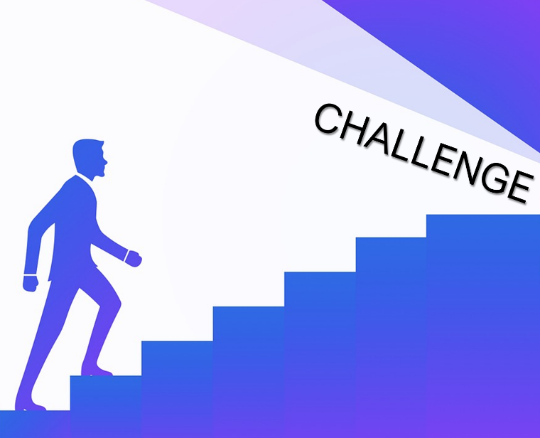They may put your mental, physical, or emotional strength into question, and many challenges test more than one aspect of your strength, too. Life’s challenges are not usually overcome with simple solutions. If they were easy to solve, they wouldn’t be a life challenge, now would they?

Learning to face and overcome life’s many challenges is an important skill to cultivate and refine throughout your life.

Learning to build your inner strength, create the right mindset, hone your ability to remain resilient, and build your store of problem-solving skills are just some of the many constructive ways you can deal with and overcome the top challenges you will encounter in your life.

This guide was created to explore some of the most common and often most difficult challenges you may face in your life. By understanding these challenges, we can identify the best possible solutions as well as apply those lessons to other areas of our lives.

Throughout this guide, you will learn what it takes to overcome life’s challenges, including real solutions for everyday obstacles and setbacks that are a part of being human.

You are not alone in your struggle against life’s many circumstances and upheavals, and this guide will help you come out on top and a stronger, happier person because of the challenges you have faced.

# Top 15 Reasons We Must Learn To Face And Deal With Life Challenges

Why should we face challenges and work so hard to overcome them? Isn’t it just easier to let the situation work itself out? Can’t I just pretend everything is fine, and eventually it will be? Unfortunately, one of the worst things you can do is ignore a significant life challenge.

It won’t go away or get better, and you are losing out on valuable opportunities to learn and grow, too. There are many reasons why you must learn to face and deal with life’s challenges. Here are the topmost important.

## There Will ALWAYS Be Challenges In Life

The first reason you need to learn to face and deal with challenges is that they will always be there, no matter what. Denying their existence is like saying you refuse to deal with and face aging or that you need food and water to survive. Life IS a challenge. And when you decide to ignore this aspect of life, you aren’t living. So, to embrace the messiness and struggle that is life, you must accept that learning to live with challenges is an integral part of being a healthy, functioning adult.

## Challenges Help You Develop Perspective

The harder times in life help you to appreciate your gifts and blessings even more. Without low points, you have nothing to compare the higher points to, after all. Challenges are what make life interesting and keep you on your toes, and they enable you to be grateful for those things that bring you joy and peace.

## Facing Challenges Helps You Become Stronger

When you learn to confront and solve the problems of life, you realize how much inner strength you have. You realize that you can take care of yourself, no matter what life has in store, and you build confidence in your abilities to solve problems, stand tall in the face of adversity, and believe in yourself. The more confidence you feel, the better able you are to tackle the next challenge life sends your way.

## Challenges Nurture Your Mind

When you adopt the right mindset toward facing the challenges in your life, you will soon realize that these experiences are opportunities to learn.

The reason these experiences are challenging is that we are faced with unknown obstacles, are being asked to do something we have never done, or need to find new reserves of strength and resolve. All of these are paths to growth and evolution. Without challenges, you would never learn new things or become a different person.

## Challenges Build Your Emotional Reserves

Learning to face and cope with obstacles, failures, and other problems in life is how you develop and tap into the emotional reserves that are lying dormant within you. It is only through challenging times that you need your determination, resiliency, perseverance, and other traits that will see you through your difficulties.

When life is easy, you do not need these aspects of your mindset, but challenges help you hone and cultivate them, preparing you for the next obstacle in life (which will come whether you like it or not).

## Facing Challenges Extends Your Comfort Zone

One of the reasons challenges are so hard is because they force us to try new things, feel new ways, or exist in areas of our lives that are uncomfortable. When you accept problems and decide to face them, instead of shrinking away from them, you stretch yourself and move outside your comfort zone, thus expanding the possibilities for your future self.

Every single thing you have ever done in your life was, at one time, new to you. So, the more you stretch yourself and push beyond your normal boundaries, the more you learn about yourself and the world.

## Ignoring Challenges Just Makes Them Come Back Again And Again

Those things we push away in life have a funny way of showing up again when you refuse to deal with them. Until you make peace with your problems and challenges, they will resurface, and the pain you suffer will intensify over time. You can’t escape yourself, so the sooner you learn to deal with your problems, the sooner you can get back to living the life you want.

## Challenges Can Reveal Powers You Didn’t Know You Had

Misfortunes often reveal parts of your personality that you did not know existed. When you are faced with new situations and obstacles, you must make hard choices, and when your back is against the wall, you may find inner reserves and abilities you never knew you had. Accepting and dealing with challenges is a chance for you to get to know more about yourself, and to find inner reserves you have previously untapped.

## Challenges Are How We Change

When you face no challenges or risks in your life, you will never change or try new things. When you know what to expect, you behave in the same way you always have, but when faced with setbacks or failures, you have to try something new, which contributes to your evolution. Adaptation is necessary for dealing with life’s many problems.

## Through Challenge, We Connect With Others

One of the factors that will contribute to your success in overcoming obstacles in your life is your support network, the people who will stand by you during life’s many challenges. When the chips are down, you realize who the most important people in your life are, and you develop stronger bonds amid the turmoil. When you are truly open, you realize that you can learn a great deal from others during times of challenge in your life, as well.

## Challenges Are Opportunities

When faced with problems, you have choices. When your mindset is oriented toward growth and positivity, you realize that whatever challenges you are facing are merely opportunities for you to learn something new. With the right mindset, you can turn any situation into a learning experience.

## Challenges Prove That You Are Taking Risks

Many people try to avoid challenges by trying to maintain the status quo in their lives, but that is no way to live. Changing your life, taking risks, and trying new things are what make life exciting and unique. When you face obstacles, it means you have gone out of your way to test yourself and try something new to you. Embrace this change!

## Challenges Teach Us That Nothing Is Impossible

When you stand up and face your challenges throughout life, you soon realize that nothing is out of your reach, so long as you maintain your mindset that you can overcome whatever obstacle you face. And the more challenges you face, the more you stop allowing others to say “no” to you or take you for granted, as you have the inner strength to stand up for what you need.

## Become A Better Problem Solver

Life’s challenges give you unique and interesting problems to solve, and the more you embrace these obstacles, the better you will become at solving those dilemmas. Challenges teach you how to look for innovative solutions, find support, devise alternate pathways, and find new reserves within yourself, all of which can benefit every aspect of your life.

## Gain Satisfaction From Your Accomplishments

When you have overcome a challenge in your life, you feel pride in yourself and satisfaction in your ability to rise to the circumstances. Overcoming a problematic obstacle means you work hard, and at the end of the day, that is a great feeling to know that you prevailed.

# The Only Control We Have Is How We Deal With Challenges

There is not a single person on this planet who does not face challenges in their life, it is a very real part of the human condition. Whether you are rich or poor, beautiful or plain, young or old, you are not immune to problems, obstacles, failures, or setbacks.

* The human condition is just overcoming one challenge after another, a series of lessons and issues that start when we are born and continue until our last breath.

No amount of money, education, prayer, or denial can protect you from the whims of the universe. It is simply not possible.

* Instead of expending all your energy in trying to eliminate, ignore, or otherwise prevent problems from occurring, you are better served to focus on the one thing in life that is within your power- your thoughts and actions.
* The only control you possess in this life is how you choose to respond act and deal with everything that happens to you in life.
* When you have a mindset that accepts and recognizes that challenges are a part of life, it makes learning to overcome them much easier.

When you accept these facts, you will be able to overcome anything that comes your way AND enjoy the easier times that much more.

# Top Life Challenges And How To Overcome Them

There are many types of challenges you may face in your life. And what is challenging to one person may not be so to someone else. Your challenges are unique to you and your circumstances, but many strategies can work to help you overcome all sorts of problems that you may face.

The following discussion represents the most common life challenges, and within each are some strategies or advice on how to handle each. While some are more specific to certain problems, others are more universal.

## Dealing with Change

Change, like many of the other significant challenges in life, is inevitable. You cannot escape it, and you cannot always control when change comes into your life. Change is scary for many reasons, not the least of which is that it disrupts our subconscious mind, which runs on routine, status quo, and familiarity.

When things are different, this deep but influential part of your thinking rebels immediately, sounding alarm bells and acting like the sky is about to fall. And because this is a subconscious reaction, it is often difficult to control or manage, especially at the beginning of significant changes to our lives.

While most of us want to escape from change or ignore it altogether, the better way of approaching change is through control and coping strategies. Instead of avoiding the change or the reality it brings to your life, you should instead take a more proactive and positive approach toward change. Instead of standing on the outside looking in or allowing change to happen TO you, you take the reins as best you can and learn to become a PART of the change process.

Learning to see change as an opportunity, just like in disappointment, grief, and failure, you embrace the possibilities that come with change instead of lamenting the loss of your former reality.

The stages of coping with change are like that of grief because dealing with change is, in some ways, mourning your old life, the death of what used to be “normal” for you. You may experience shock, denial, anger, bargaining, depression, and, eventually, acceptance. Until you accept the change, you will struggle to move forward and be happy.

The more resiliency you have and the more positive your outlook, the easier it will be to cope with significant changes in your life. After coming to terms with your situation, it is essential to look for the lessons you can learn, analyze your situation, determine your new goals, and devise an action plan for moving ahead.

Change comes in many forms throughout our lives. Even when the change is voluntary, it is still difficult to let go of our routine, adopt a new life or mission, and become a new “you.” Make the most of change by taking care of yourself, learning to cope with the stress of change, embracing the possibilities that change can create, and taking charge of how you respond to changes that life may throw your way.

## Life Unfairness

No matter how many times it happens to you, it is still difficult to accept that life can be incredibly unfair at times. Just when you think you have overcome a significant challenge; you are met with another. Or, a series of problems or setbacks plague you. Or something horrible happens to you despite your best efforts to prevent it. It is not fair. It is never fair.

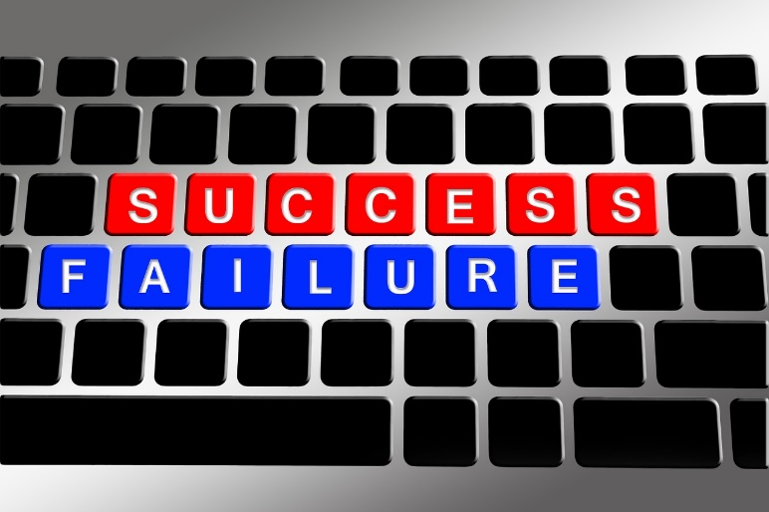Learning to cope with the unfairness of life can be quite challenging, especially when that unfairness results in the loss of someone you love, a significant failure or disappointment in your life, or an unexpected change that transforms your entire world. And the first step to coping with this major life challenge is accepting the unfairness of it all.

This may seem like a common refrain at this point in this book but learning to accept unfairness in life is embracing the idea that the only thing you can control is your thoughts and actions. That’s it. Nothing else is within your sphere of influence, as much as you would like to believe.

Learning to accept the things you can’t change (and the courage to change those you can) is a familiar adage, but what is most powerful about that prayer is the part about having the wisdom to know the difference. Change your mindset to embrace the power you have over yourself and your thoughts and actions and learn to let go of disappointment about those things over which you have no control.

## Job Loss/Career Challenges

For many people, their job is a significant part of their identity, how they define themselves or show their value to others. So, when you unexpectedly lose your job or you are facing challenges related to your career, it feels like a significant challenge. And depending on the status of the economy, your ability to rebound from the situation can be harder than you like.

While certainly feelings of anger, disappointment, anxiety, and embarrassment can all accompany a sudden job loss or demotion, how you respond to and allow these emotions to affect you is crucial.

For starters, it is necessary to acknowledge that your situation is extremely stressful. Accepting that your life very hard allows you to process and feel the emotions that come with them without holding them in so that they can (and will) erupt when you are not prepared to deal with them.

Evaluate your situation as rationally as you can to determine your financial status, options, and desires. What can you learn from this experience that will help you in the future, including anything that could prevent such events from happening again, if any?

Looking at an unexpected job loss as an opportunity is also helpful. You have the chance to find something better, explore your talents in new ways, and grow in your knowledge and skills. If you could pick any new career path or job, what would it be? Make this the right time to pursue this new dream. Determine if you can apply for benefits, assistance, or financial aid that would allow you to receive job training, further education, or funds to open your own business.

When you are out of work is a wonderful time to work on yourself, reevaluate your own needs and dreams, and make new long-term goals for yourself. Take advantage of this opportunity to focus on what is important to you, then use your time to find new opportunities that are aligned with this new plan.

Staying positive and focused on the future will be necessary during times like these, so your mindset is particularly crucial. Remember that your job is not who you are, and just because you have experienced a setback does not mean you are a failure. Many job changes are less about you and more about the company’s bottom line, so keep things in perspective. A positive outlook will also make you more appealing to potential employers.

Make sure that you are taking care of yourself during this stressful time. You need all your mental, emotional, and physical strength during times of high stress, so be kind to yourself. Exercise, eat well, avoid unhealthy habits, and get outside in the fresh air when you can. All of these will help lower your stress and give you the energy to remain resilient.

## Heartbreak and Failed Relationships

Heartbreak hurts for several reasons. When we lose someone we love, it can cause an avalanche of feelings and worries that can become a significant challenge in our life. A failed relationship can spark self-doubt, fears about the future, worry about being alone, depression, anger, and discontentment.

Learning to live and cope with heartbreak is not unlike learning to live with a significant loss or disappointment in your life, and you are likely to go through many of the same stages as you would with these other, similar challenges.

Whether the relationship ended because of a decision you made or the other person, learning to accept what happened is the first step toward coping with this loss. Allow yourself to feel the hurt and sadness, to accept that your life is not going to change and that you may have played a role in this situation. Come to terms with your part in the breakup and remember that it is okay to feel sad about this loss.

Express your feelings and talk to others who can help you through this difficult time. Releasing the negative emotions and thoughts you have about the other person will be important, as well. Don’t wallow or dwell in the past.

Think about what you can learn from this situation and promise yourself to apply those lessons to future relationships. If you want to be better, you must do better. Remember to take care of yourself during this time and get help when you need it.

It is vital to move on from past relationships. Cut ties with your former partner and remove things from your life that remind you of them. Focus on new activities and interests and on setting new goals for yourself.

Try to meet new people and stay socially active, and it can even be therapeutic to help someone else who is struggling, too. Be patient, and, with time, your heartbreak will lessen, and you will feel confident about moving on with your life.

## Financial Crisis

For some, a monetary crisis is something you feel nearly every day of your life because you are living so closely within your means that any minute feels like it could bring financial ruin.

For others, financial problems may come on very suddenly after an abrupt change in your economic circumstances. Losing a job, getting demoted, the death of a spouse, a significant health problem, an injury that prevents you from working, or any unforeseen circumstance could change your financial situation from okay to dismal pretty quickly.

A financial crisis is a challenge that combines feelings that are similar to how you feel when coping with grief, unexpected change, unhappiness, disappointment, discontentment, and even failure. This type of situation affects each of us differently, but we each can control how we respond to this life challenge.

To tackle financial crises, do not waste any time. The sooner you can analyze, understand, and devise a plan, the better off you will be. Money problems very, very rarely go away on their own, so burying your head in the sand will not help. Cutting your expenses back to the very, VERY basic necessities will also be important. The quicker you can start giving out less of whatever money you have left, the easier it will be later.

Instead of buying anything, focus first on what you already have. What have you already purchased that can be used to meet your needs for now? What do you own that will prevent you from needing to spend any cash? Start here!

Create a plan for how you plan to overcome your financial struggles, including a budget that matches your current income. Do research, talk to people who know about the areas in which you are struggling (credit card debt, underwater mortgages, healthcare debt, etc.), and get advice about the smartest moves for you. Then, start implementing your plan by taking small steps every day to deal with your problem.

In some cases, taking out a home equity loan, a personal loan, or borrowing money from family or friends maybe your best option, and in others, incurring more debt is not the right choice. If you have assets you can sell to raise cash, now is the time to do it. Not every financial solution is right for every situation. Choose those that work for your case, but whatever you do, be sure you are actively working to solve the problem.

## Major Disappointments

Disappointments occur all the time. What makes these significant life challenges is when you are disappointed because of something major or important in your life. You may feel unhappy that you didn’t get the job you wanted, you may be angry that your spouse has been unfaithful to you, or you may feel regret that you have not achieved an important goal you set for yourself. Other people can disappoint us, and we can disappoint ourselves. The only way to not be disappointed in this world is to stop expecting anything, which is pretty much impossible to do.

Navigating past your disappointment is crucial to moving forward and coping with your emotions about the disappointing event. Remaining focused on your feelings of disappointment is to stay stuck in the past, to wallow over things you can no longer control or change. When you are ready to move on, several things can be helpful when it comes to moving past your disappointment.

As with other feelings of loss or grief, it is important to remember first that we all feel disappointment in our lives. It happens to everyone. No one gets everything they want in life. Ask around, and see just how much disappointment exists in people’s lives. Realize that it is a normal, natural part of being alive.

After acknowledging the reality of your disappointment, it is crucial to analyze what happened. What led to this conclusion, and what can you learn? Be clinical in your thinking, which can help you devise better action plans in the future.

Change how you talk to yourself about your disappointing outcome, too. It was not a failure; it was a learning experience. It is not WHO you are but rather something that happened. Only you can determine if your disappointment will be a lesson or an opportunity to stop growing. You have the power to make that choice for yourself.

## Dealing with Your Reality Just as It Is

Rejecting reality happens for a variety of reasons, usually in response to significant setbacks, disappointments, losses, or failures. When you reject reality, you are using unhealthy coping strategies that cause you to hold on to a version of your life that is not real, which over time, can lead to even more disappointment and sadness.

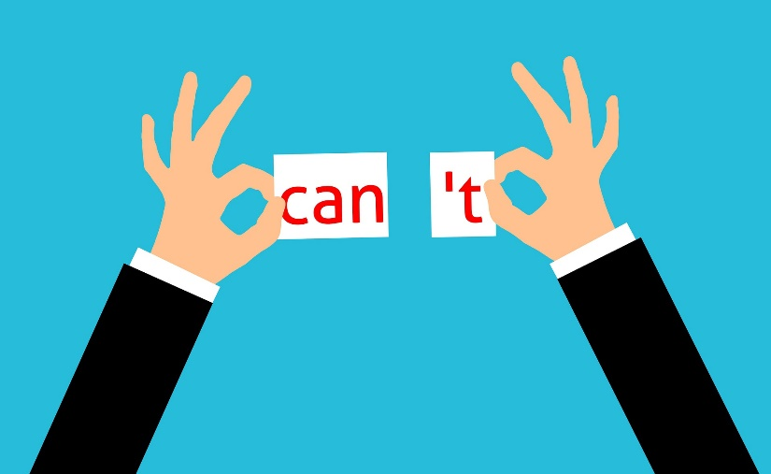Learning to deal with reality as it is can be extremely difficult. After all, when life is hard, who wants to focus on that negativity and live with the challenge? Isn’t it easier to ignore reality and pretend like things are okay? Learning to accept your truth, yourself, and your life are essential parts of being a happy, healthy, functioning person, even when times are tough.

If you want to learn to cope better with reality, then start by accepting yourself. Much of our alternative universe is based on an idealized notion of ourselves that does not translate to the real world. Come to terms with all the good and bad parts of yourself.

Learn to accept who you are and love yourself. The same is true for the other aspects of your life. Accept your current situation for what it is. When you learn to work in reality, you are better equipped to improve those parts that make you unhappy.

Accepting responsibility for yourself and your life is also important. You made decisions and choices that got you here. Own those. Accept the actions that have fostered both your success and your failure and start from a place of radical honesty to help you move forward. Let go of the fears that have been keeping you from accepting reality up until now, and focus instead on your gifts, skills, knowledge, and strengths.

## Living Life on Life’s Terms

No matter how much we would like to, we control very few things in this world. Life has a way of changing, presenting challenges, and creating problems, and you don’t get to control when these occur. Life’s terms are that it gets to decide, and your only recourse is that you get to deal with it. Sounds a little unfair, doesn’t it? Learning to live with this reality can be quite challenging for some.

The struggle to accept these blunt and unfriendly terms of life often results in harmful responses from others, which can lead to emotional or psychological harm or the adoption of unhealthy coping strategies.

Most people either decide they are indeed in control of the world, walking through life ignoring the will of the universe, and experiencing many difficulties in the process. Others become angry or cynical, cursing life and losing out on many positive experiences because they cannot accept this reality.

When you feel out of control in your own life, how do you react? The first step to conquering this challenge is to accept that you cannot control many things in this world. The only thing you really can control is yourself, your actions and decisions, and how you allow life’s whims and circumstances to affect you.

Focusing instead on managing your emotions, conquering your fears, preparing yourself for challenges that lay ahead, and being the best version of yourself you can be. Only then will you be prepared to meet life on life’s terms.

## Living in The Past or Future

When you live your life focused on the past or with sights only on the future, you create a significant life challenge for yourself, one that will lead to mental, emotional, and spiritual unrest. Why is it a problem to live in the past or the future? Well, for starters, the only thing you can genuinely react to and control is your present. The past has already happened, and the future is yet to occur.

You can’t do anything to change what has already occurred. No amount of worrying, regretting, or thinking about past events will change the outcome. Thinking about the past should focus on what you can learn from those lessons, which you can then apply to your present life.

Worrying about things that have not happened yet is also very unproductive. You don’t know what will happen tomorrow, and you have no control over how life unfolds. The best you can do is be prepared, focus on your happiness and strength, and tackle each day as it presents itself.

Practicing more mindful activities and focusing on your present life are the best antidotes for living in the past or future. Learning to meditate can help break the cycle of out-of-time thinking, too. Living in your current life will help you make the best of your existence and lead to improved levels of well-being and happiness.

## Family Issues

Families go through many different challenges. These may include relationship problems, financial stress, mental illness, death, addiction, or the loss of a job or home. Your issues may be with your spouse, children, parents, extended family, or others. And family issues are often particularly hard to navigate because these are people who are in your life and whom you must face from time to time.

Conflict within a family unit affects everyone, not just the people immediately involved. Learning to handle family issues is crucial for your well-ending, as well as the others that you love. Talking about your problems, identifying the source of the problem, and working together to solve your issues are crucial. If the problem was created as a team, the problem should be solved as a team, so coming together to work through your challenge is important.

Focus on listening to others in your family as you discuss the problem in question. Be open to their perspectives and how they feel, and when you talk, use “I statements” to ensure that others are hearing how the problem is affecting you. Avoid blaming others and accept your role in the problem, as well.

Active listening without interrupting will be critical, as will keeping your cool. Validating others’ points or needs can help them regain trust. Together, your family needs to decide on a solution that everyone can live with.

And it is especially important that everyone follows through and does what they agree to do. It may be helpful to enlist professional advice or support in cases where family issues have lasted for years or deal with significant trauma or emotions.

## Fear

Did you know that fear is perhaps our most ancient of emotions? It evolved with us as a species and became necessary for enabling humans to protect themselves from the dangers of early life.

Fear is a warning signal, and it triggers immediate responses from our emotions and our bodies. And while we still need to protect our bodies from harm, the things we fear today have less chance of killing us and more chance of harming us emotionally or psychologically.

Modern fears include being afraid of failure, being alone, missing out on happiness or contentment, or being embarrassed or ashamed. Very rarely are our daily fears related to actual issues of personal and physical safety, yet our fear response remains the same biologically. Living with low-level fear all the time, which is also known as anxiety, is harmful to your overall well-being and health.

When you are confronted by fear, it is essential first to analyze the situation. What is it that frightens you? How likely is this event to occur? Do you have any evidence to suggest that this is likely to happen? And how have you handled similar threats in the past? Taking a step back and looking carefully at your fears can often reveal that you have no grounds for your anxiety.

Deep breathing, visualization, and relaxation exercises can all help you to cope with fears, particularly those that are persistent. It is essential not to ignore your concerns, which just perpetuates your anxious feelings. Instead, confronting them and learning to work through them is necessary. We will explore more about fear in a later chapter of this book.

## Failure

The fear of failing is one of the most pervasive in your culture and dealing with any type of failure is particularly challenging. But, the reality of today’s world is that you will fail. Probably a lot. And the faster you learn to cope with failure helpfully and constructively, the more likely you are to recover from these setbacks and still achieve your goals and dreams.

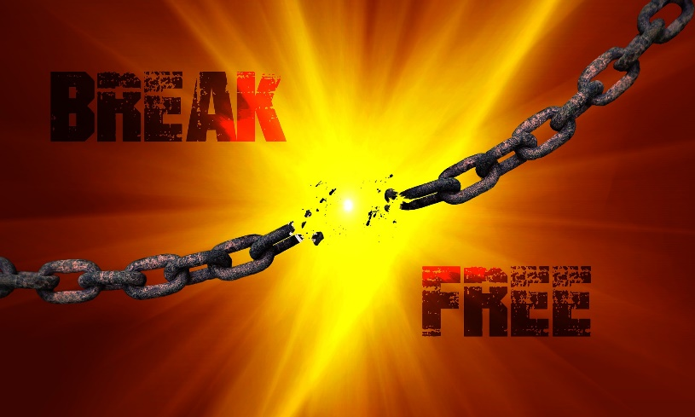The only thing you get to control about failure is how you respond to it. It’s okay to feel bad about failing. That emotion tells you that this is important to you and that it matters in your life. So, if it is important, what next?

Failure is a chance to try again, this time with more information. Learning from your failures is the single greatest gift we get in life because it means we can try again as new and better people. Focus on ways to work through your pain that also honor your well-being (see self-care tips below). Adopt stress-reducing habits that help boost your mood and create a positive mindset.

Develop a new plan that is realistic and based on what you learned from your setbacks. Incorporate new ideas and your improved attitude in your plans, too. And face your fears about failure and ask yourself if this challenge is so bad, after all.

## Learning Proper Methods of Self Care

It may surprise you to learn that not everything you do that feels good is self-care. And that most people, especially women, place self-care low on their list of priorities. Taking care of your body, mind, and spirit is an integral part of your responsibility to yourself, and yet many of us neglect this vital role. Self-care is necessary for protecting you from the stress of daily life, and learning to do this, especially when you were not taught to as a child, is a struggle for many people today.

Self-care is any activity that not only makes you feel better but also promotes better health for you in some way. That may be improved spiritual or mental health or better physical health, but self-care is things that you do that do not also cause eventual harm. Sorry for some of you, but that means your three glasses of wine at night do not qualify as “self-care.”

When you learn to care for yourself, you have more to give to others, too. Self-care helps you feel good about yourself, raises your self-esteem, and improves all aspects of your life. Developing a plan for self-care can be hard, but you must start by identifying the areas of your life where you are neglecting your wellness.

Do at least one thing each week in each of the areas where your self-care is lacking. Focus on all aspects of your health as well as your relationships and professional life. Neglecting one part of your holistic wellness can cause other components to become overloaded. Reevaluate frequently to determine if your efforts are making a difference and if you need to alternate self-care strategies.

## Health Problems

Health problems represent a top life challenge for many people today. Whether it is challenging because of its chronic effects, its financial burden, the reality of how it changes your life, or because it represents a loss of mobility or cognition, dealing with health issues is extremely stressful and can change your life.

Living with a chronic condition, a terminal illness, a debilitating injury, or cognitive decline are all extremely hard to handle, even for someone with optimal well-being. And when your body or mind stops cooperating, you can feel betrayed, scared, angry, and depressed. Like other types of challenges, ignoring health issues will not make your situation better, so the first step toward coping is to learn as much as you can about the problem you are facing.

 Researching your health problem, talking with your doctor, meeting with others who are also struggling, and asking questions will help you be better prepared to address this life challenge. Building a team of people, including friends, family, your partner, and others will give you the support you need to weather challenging times.

Be sure to look holistically at your wellness, too. While it may seem like you just need to focus on your condition, it is also essential to maintain all aspects of your well-being. Be sure to follow the advice of your doctor, stay engaged in your care, and become an advocate for your well-being.

Ask for help when you need it, particularly if you start to feel depressed or overwhelmed by the challenges you are facing. If the health challenge is someone else’s, someone for whom you care, be sure you are getting help from others in your family or community, too.

## Discontentment or Lack of Fulfillment

Feeling discontentment is being dissatisfied with your life’s circumstances. You may feel unhappy or frustrated by the prevailing direction of your life, or you may be discontented with only certain aspects of your life. This emotion represents an unmet need. There is part of your life that is not whole; something is missing. When that missing piece is from a sizable portion of your goals or dreams, your feelings of discontentment can feel overwhelming and influence all other aspects of your life.

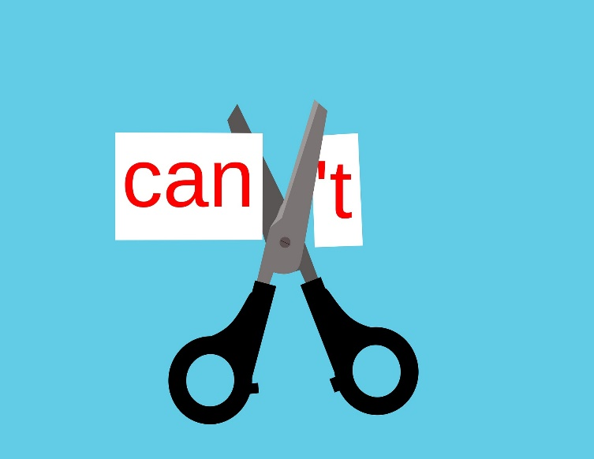When you feel discontent, you must identify precisely which part of your life you are lacking. Evaluating where you feel unfulfilled will help you confront this challenge more productively. Once you know the issue, you can either change your perspective or attitude about this particular aspect of your life, you can do something to positively change your life to rectify this unmet need, or you do something that will give you meaning and purpose in your life, which can help you to deal with discontentment stemming from problems within yourself.

Often, people with many blessings may experience discontentment because, while they have much in the way of tangible things, they lack purpose or work that has meaning. Finding something that is worthwhile and brings you joy as well as purpose is necessary for confronting feelings of discontentment.

**To start feeling more content in your life, try these initial steps.**

1. Let go of the regrets you have. You will never find fulfillment and contentment when you are hanging on to regrets of the past. Letting go of our mistakes and failures is the only way to move forward and find peace.
2. Stop feeling entitled to something. This world owes none of us anything. The sooner you realize this, the sooner you can start working toward what you want. Stop expecting things to just happen for you and get busy making those come true.
3. Learn from every experience. You can become more fulfilled just by looking around at all the goodness and possibility in your life already. You can learn and become a better, stronger, more giving person, which can help you feel more fulfilled.
4. Think about more than just yourself. Being fulfilled often happens when you can help other people or bring peace or happiness to someone else’s life. Look for ways that your life can make the world a better place.

## Lack of Motivation

 Motivation is your reason, desire, or willingness to behave or make choices in a particular way. It is essentially your reason for doing just about anything in life. You are motivated to eat by hunger, but you may be prompted to eat healthier because you want to live longer and be able to enjoy your life with your family.

Motivation requires three necessary components for it to work. First, it needs the spark, the catalyst that turns any promising idea into concrete action. You may love to paint, but unless you are inspired to pick up a brush and put paint on a canvas, you are not motivated to pursue that love.

Next, you need fuel. Motivation needs to last; it must endure past the boring parts (of which there will be plenty) as well as the obstacles and setbacks (of which there will likely be lots). Motivation only works when it lasts beyond the initial action and helps you develop a new habit or keeps inspiring you to act again and again.

Finally, motivation needs a result, which can often fuel future motivations. I may be super motivated to lose weight, but if I work hard for over a month and do not see any results, I am likely to lose my motivation and give up.

**If you are feeling unmotivated, there may be many reasons why. Some of the most common include:**

* Not having a strong enough reason why you need to do something.
* Your goal is enormous, and you don’t know where to start.
* You lack confidence in your ability to succeed, so you stop trying.
* You have too many other priorities in your life, so you lack the resources to devote to this goal.
* You are afraid, so you don’t try.
* You are making other choices that are preventing you from staying motivated to meet a specific goal.
* Your goals are unrealistic.
* You aren’t giving yourself enough time to meet your goals.
* You don’t know where to start.
* Your emotional or mental health may be interfering with your ability to stay focused or to find a positive outlook.
* You have a fixed mindset that is interfering with your ability to see how changing can help you grow.

To improve your mindset and jump-start your motivation, you need to analyze the source of your problem and devise a plan that meets that need. Once you realize that motivation is just in your mind, you can decide to do something about it and change your thoughts.

## Unhappiness

Feeling unhappy now and then is a natural part of life and happens for a variety of reasons. While there may be circumstances, events, or people that can contribute to your unhappiness, there are often times that you may be contributing to your sadness, or your efforts to overcome these negative feelings are not successful.

The first step to dealing with feelings of unhappiness is to evaluate why you feel this way. Start by accepting your feelings, which gives you permission to examine them and discover the source of your emotions. Write down everything in your life that may be causing or contributing to your feelings of unhappiness, including events in the past that may have resulted in lingering feelings for you.

Look for patterns or triggers that could be part of the problem. Most of the time, feeling unhappy is temporary or a situation and resolves in due course, but similar situations or reminders of past troubles can often leave you feeling miserable when you aren’t even really aware of why.

Be specific about identifying the cause of your unhappiness. While it may seem like you feel this way because of a particular event, perhaps there is a deeper, more important reason that is leading to these feelings. Talking about your feelings with others can help not only process your emotions but also to identify the actual causes of your unhappiness.

Decide to deal with those factors that are related to your unhappiness over which you have control. What decisions can you make, or changes can you adopt that will help you resolve your feelings? If you are unable to resolve your emotions on your own or start to realize some improvement over time, it may be necessary to seek professional support to enable you to get past this challenge.

## The Reality of Aging

None of us wants to get older, but if you want to keep living on this earth, then that is the reality you must face. Aging comes with a wide range of problems, including how our bodies and minds are altered by time. For many, aging brings on feelings of grief over lost youth or opportunities. Many older people struggle with feelings of discontentment or lack of fulfillment. Financial and health crises are much more common as you get older, too.

To be able to deal with the challenges that aging presents to us all, you must first know what to expect from getting older. The information allows you to make plans for your well-being, your financial welfare, and your wishes for your end-of-life care. Knowing what could happen as you get older means you will feel less afraid of what comes next, and you can become more proactive in protecting yourself as much as possible from the effects of aging.

Taking care of your body is a crucial factor in dealing with aging. The healthier and stronger you are throughout your life, the better you can expect to age gracefully and experience fewer medical problems.

Eat healthy foods, get plenty of exercises, stay flexible and strong, and cultivate healthy habits throughout your life, which will benefit you immensely when you get older. A positive attitude, a plan for staying active and engaged with others, and finding ways to feel needed and fulfilled are also crucial to coping with aging.

## Grief and Loss

Grief is an emotion we feel in response to loss. When something or someone you love is suddenly gone, you suffer emotionally in its absence. Grief can also occur when you realize there are losses within yourself, for example, an unfulfilling childhood. Grief can be felt after a missed opportunity or a failure. It can also be felt for someone who is grieving or even for the world when horrible acts occur, such as violence. Depending on the loss, your pain may feel overwhelming or impossible. And grief can occur because of the loss of many vital things in your life.

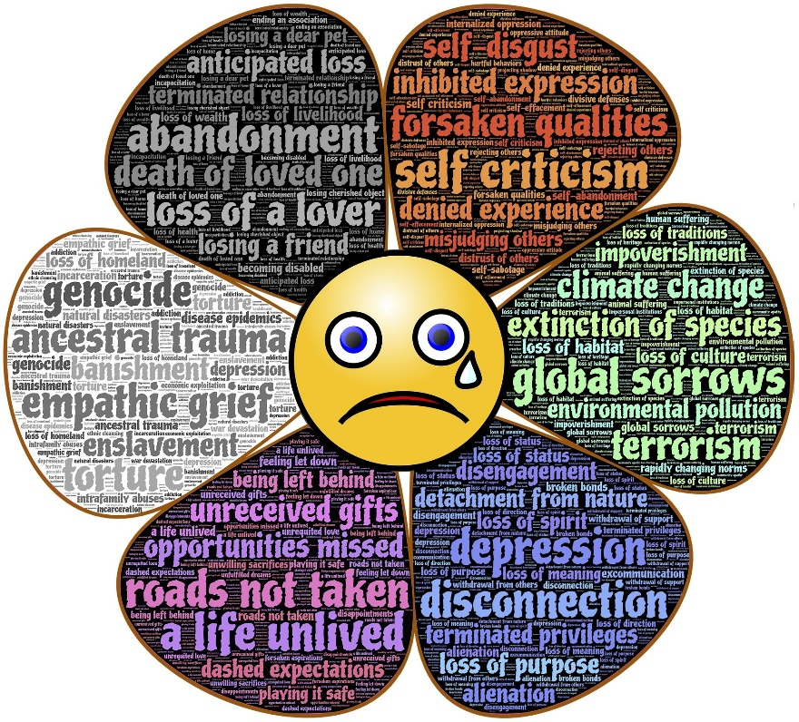In addition to the most common, which is the death of someone you love, you may also feel grief over the loss of a long-term relationship, your personal control after a violent assault, your approval from others when you lose credibility, your safety after a natural disaster or terrorist attack, or the loss of your way of life after retirement or other significant life change.

You can feel grief about the loss of anything in your life that is important to you, and it does not matter if other people are also grieving or understand your loss. You still feel it and need to learn to deal with it. The more significant the loss you experienced, the more intense your grief will be.

Grieving is normal and something you should not try to ignore or push aside. It is how you come to terms with the loss and learn to move forward productively.

Without properly grieving someone or something, you may feel that loss profoundly for many years to come. Coping with grief means that you come to terms with your loss, find meaning in this challenge, and learn how to move on with your life.

Most people who experience significant loss experience one or more of the five stages of grief, which include denial, anger, bargaining, depression, and acceptance. But these stages are not linear, not everyone feels all of them, and your grief may go back and forth between these stages, sometimes erratically, for extended periods. Simply knowing that these types of reactions are healthy, and part of the process can help you through your grief.

**To learn to live with your new loss and cope with your feelings of grief, you should:**

* Look for support to help you through this hard time. Friends, family, clergy, and mental health professionals are all reliable sources of support. You may find it helpful to talk with others who are grieving, as well.
* Accept that other people may not know how to help you deal with your loss. Grief is confusing and not talked about in most cultures, so many people may not be sure what to say or do to support you. Don’t take it personally. Reach out to them when you need help.
* If you have a strong belief system or religion, you may find comfort in the rituals or doctrines to which you adhere.
* Look for lessons you can learn from this tragedy. What can you take from this experience to inform your life now?
* Take control and create a plan for your new life after your loss. What goals do you have, and how do you want to accomplish them?
* Be kind to yourself and realize it will take time to fully process and come to terms with your loss.
* If your grief has lasted for an extended period, and you feel like you are not coping any better, get help from a professional.

## Criticism from Others

For some people, learning to hear, accept, and respond to criticism from others is a top challenge in their lives. Criticism that is offered to help you grow and change is one thing, but criticism that is provided to hurt you is something else altogether. But, both types of criticism require you to do the same things.

First, you need to decide the intent of the giver. Once you understand where this person is coming from, you can examine the criticism to determine its validity. Do they have a point? Is this important to you that you want to work on? Finally, you must decide how to respond to criticism.

In cases of destructive criticism, your response can protect you from the harmful intentions of the other person. Does this person matter in your life? Do you care or value what they have to say? Are they trying to help you? Ignoring destructive criticism can be hard, but it is the most powerful weapon you have to fight back against bullies and others set on hurting you.

When it comes to constructive criticism, though, you can choose to learn from what others are saying instead of taking their comments personally or believing they have ill intent toward you. By embracing a growth mindset, you realize that we all have room to grow and learn in life, and someone is trying to show you ways in which you could improve, too.

Embracing your imperfections and accepting your fallibility is essential, as it learning to accept feedback without taking it personally. If the intention of the other person is helpful, they did not mean to hurt you, so why automatically assume they were? And embracing yourself as a flawed human, as we all are, allows you to accept that others may have valid points when offering criticism.

Ultimately, you get to choose how you respond to others’ feedback. You can’t control anything that someone else does, but you are in charge of your reaction to it. When it comes to criticism, you must determine the value and worth of the feedback and then decide how much you want to let this advice influence your actions. The choice is yours.

## Dealing with Difficult People

From time to time, we all have our difficult moments, times when we do not act our best. But, when someone is chronically difficult, they can be tough to deal with, especially for those who interact with them regularly. Maybe it is your mother or another family member.

Perhaps you have a difficult co-worker. Or maybe your spouse can sometimes be hard to live with. Dealing with difficult people places you under a lot of stress, and if you don’t learn to handle these situations well, you can end up feeling bad all the time because of one person in your life.

It is important to note that difficult people are often so because of their problems and unhappiness with themselves or their lives. Most of the time, they are difficult toward everyone, so there is no point in taking anything they say personally. Their unhappiness is not about you, and there is nothing you can do to change them.

After you have accepted this, you can learn new ways of interacting with the person who is challenging to make it easier to navigate their stressful waters. Start by remembering that not every occasion is worth the fight. If you know it will be an effort to deal with someone, you need to determine if the effort is worth the outcome. If not, do not engage. It’s not worth picking every battle with someone difficult.

When others are being difficult, deep breathing exercises can help you pause and regain composure before you allow your emotions to get the better of you. Allow your emotional response to quiet down before you attempt to deal with someone hard to handle. When talking with difficult people, it is helpful to speak in terms of facts, needs, and statements and avoid opinions, demands, or anything that they can misconstrue.

Whenever possible, minimize your interactions with the problematic person, limiting your time with them to the barest minimum necessary. It may be helpful to bring someone else into the room with you when dealing with them to diffuse the situation.

It is better to take the high road when it comes to difficult people. Be polite, keep your cool, and try to be the better person, no matter how hard it may be. Don’t sink to their level, because while you cannot control them, you can control yourself.

## Existential Crisis of Struggling with Self-Identity

Someone who is having an existential crisis is pondering some big questions that include the meaning of life, the purpose of their existence, or the reason we are here. These are weighty questions that can plague anyone, especially those who are struggling with their identity or happiness.

Wanting answers to the big questions in life does not have to be a threat, but it can be a significant challenge to find your way back to happiness and fulfillment.

We all search for meaning and purpose in life. It is part of human nature. When you find no satisfying answers, though, an existential crisis can set in. When some people lack answers to these loftier questions, they feel conflicted internally and become frustrated, depressed, or fearful of the future. While these types of challenges can come at any time, they are often accompanied by other kinds of crises in your life.

In general, an existential crisis is caused by a shift in your emotions or perspective. It often results from despair, loss, guilt, dissatisfaction, discontentment, or a refusal to cope with your feelings healthily.

Finding purpose in life can help you to resolve your struggles with identity. Taking control of your thoughts is the first step to breaking the cycle of negativity that often accompanies this type of challenge. Focus on your gratitude and strengths. Write down all the ways your life has meaning and value.

Learning to be okay without having all the answers is tricky and may require help from others. Talk with a mental health professional if your efforts to resolve your existential crisis have not helped.

# Understanding What Is Important in Life

Many of life’s challenges are caused by a disconnect between our values and our actions. When you focus on what is important to you in life, and you align your decisions, words, and choices with those beliefs, you will enjoy inner peace and contentment, which helps you deal with life’s challenges in so many ways.

Learning what is important to you is the first step to rebalancing your life, solving many internal and external challenges you may be facing, and becoming better prepared to deal with the more significant setbacks in life. So, how do you re-prioritize and realign?

**#1. Focus on the critical relationships in your life**

No matter the challenges you face in life, you need an effective support system to enable you to cope successfully. Start by identifying all the important people in your life. Make the conscious choice to recognize the role they play and the contributions that make. Those who are adding nothing to the party or who are contributing to your problems should be reevaluated to see if they should remain on your list.

**#2. Recognize that you are worth it**

Many times, conflict arises because you settle for less than you wanted or because you are afraid to say what you need. These behaviors stem from a lack of self-worth, which can be a contributing factor in several of life’s challenges. Focus on building yourself up, accepting that you deserve happiness and joy.

**#3. List your strengths**

Catalog your qualities, strength, skills, talents, gifts, and competencies. These are areas you can rely on in times of trouble, and they are the ways that you can find enjoyment and satisfaction in life. Think about all the things you enjoy doing, too. These are opportunities to feel important and to do good for yourself and others in your life.

**#4. Identify your beliefs and values**

There are many ways to go about this, but the goal here is to figure out who you are at the core. Make a list of the values that are most important in your life. Use these to write your own personal code of conduct, and a mission statement for your life that helps you identify your beliefs and mission.

**#5. Choose goals that align with your code**

Once you have a good idea about your values, it is time to apply those to everything you do. Your long-term, short-term, and daily goals should all be in service to your mission statement. Those things that are not aligned or go against your personal values will cause conflict and stress and represent significant challenges to your happiness.

The more you decide to do what makes you happen in life, embrace your values and beliefs, and disregard people and activities that go against your code, the more at peace you will be and the fewer challenges you will face in life.

# The Illusion of Control

The idea that we can control our lives is so pervasive and yet so false. Throughout this book, we have explored all the ways that you lack control in your life, as well as the simple truth about where we have complete control in our lives.

 Consider the challenges we have already addressed. Which of these is really within our control? Can you control if someone dies, if you become ill, or if other people criticize you or are difficult to be with? No! Can you control the fact that life is full of change, disappointment, unfairness, and heartbreak? Nope. We can’t even control our bodies as they age.

So, you might be thinking, well, I guess I can control my emotions. But guess what? You really can’t. You can’t control that you miss someone who is gone, that you feel disappointed over losing a job, or that you are discontented in your life. These are reactions from your subconscious, and they are part of who you are.

No, what you can control, through all these challenges in life, is how you respond to them. You get to control your reactions, your thoughts, and your decisions. That’s all. You can manage your response to the critical or challenging person, how you tackle a financial or health crisis, what you do about your unhappiness or lack of fulfillment, and how you accept the reality of aging or living on life’s terms. You get to control your words, your goals, your behaviors, and your mindset in every single one of these situations.

Control is an illusion when it comes to life, other people, fate, your emotions, and just about everything else that happens each day. But when you embrace the one thing you can control yourself, then you will realize that this is all the control you will ever need.

# 10 Inner Traits You Need to Overcome Any Challenge You May Face

In addition to learning specific skills and strategies that can help you triumph over challenges in your life, there are also specific personality traits that you can cultivate that will make it more likely that you can overcome the various adversities in life. Here are ten inner characteristics that can help you overcome the challenge.

**#1. Courage.** The more courage you have, the more determined you will feel when standing up to adversity. Courage gives you strengths, from which you can draw upon when faced with setbacks or obstacles. You can cultivate courage in many ways in your life, including exposing yourself to situations and people that are outside of your comfort zone regularly.

**#2. Mindfulness.** Learning to live in the present and let go of worries about the past or future can reduce your stress and help you deal with the challenges in the present. Mindfulness enables you to keep things in perspective, too. You can work on being more mindful by practicing meditation every day.

**#3. Curiosity.** When it comes to dealing with challenges in your life, it is immensely helpful to have a curious disposition. This keeps you asking questions and seeking information, which is more likely to help you overcome obstacles. The more information you have, the better equipped you are to make good choices that will help you overcome challenges.

**#4. Calm.** When you are calm, you can think clearly about your situation, balance your emotions, and respond to challenges with more rational rather than emotional reactions. Calm can be achieved in many ways, including through deep breathing, meditation, and various relaxation exercises.

**#5. Honesty.** When you are honest with yourself as well as others, you feel more at peace within yourself, which enables you to feel prepared to address life’s challenges. Honesty is a way to remain open to others, who can be instrumental in your ability to cope with setbacks, too. Focus on being honest with yourself and expressing yourself honestly as much as possible.

** #6. Confidence.** When you have confidence in yourself, you know that you can rely on your strengths and gifts to achieve your goals. The more confidence you have, the more self-assured and worthy of happiness and success you will feel. Work on building your self-esteem by focusing on your strengths and remembering times when you were courageous.

**#7. Empathy.** When you feel like blaming others for the challenges you face, remember that you may not know what is happening in your life. Everyone you meet is facing a problem you don't know anything about, and the best you can do is control your response to people who make your life more challenging.

**#8. Gratitude.** When you focus on being grateful for what you have in your life, you realize you have many more gifts than problems. Appreciating what you have and the people in your life will enable you to take advantage of the support you have when times get tough. Take time every day to name and consider your gratitude.

**#9. Grit.** This trait exemplifies your strength of character, which will enable you to overcome all of life’s challenges. Grit is what will see you through the hard times and enduring difficulties, and you can build this trait by trying new things and trying out new activities that test your strength and make you feel uncomfortable.

**#10. Enthusiasm.** Having a positive outlook and focusing on your passions can help you overcome even the darkest times in your life. And the more enthusiastic you are, the more people will be willing to help you and be there for you when you need them. Find something every day that makes you smile and encourages positive thoughts and feelings.

# Proper Mindset To Face Life Challenges

More than what you know, facing and dealing with life’s challenges is accomplished by your mindset. Learning to think with positivity, perseverance, and resilience will be crucial to your ability to overcome obstacles and face real-life challenges.

## The Role of Positive Thinking in Facing Life Challenges

Positive thinking can help you in the face of life’s many challenges in several essential ways. For one, when you have a positive mindset, you respond to stress differently in your brain and body.

A positive attitude can help to reduce the negative influence of stress hormones on your body. The more stress you feel and the higher your levels of stress-induced hormones, the harder it is for you to think rationally and control your emotional responses.

The more you think positively, the more your brain reaches for positive outcomes and solutions in times of crisis. Long-term positivity rewires the brain to seek solutions, believe in good results, and feel more optimistic when trouble begins. And the more positive your brain is oriented, the more likely you are to use your rational, logical mind rather than your emotional one.

When you are positively oriented, you believe in excellent outcomes and can place your challenge into perspective. And the more you think that you can find a way to deal with your problem, the more likely you are to do so.

A positive mindset is crucial for developing perseverance and resilience, two other mindsets that are vital when it comes to overcoming challenges in life.

# The Role Of Perseverance In Facing Life Challenges

 Many of the challenges you face in life will not be easily solvable or surmountable with one solution or minimal effort. Some of the more substantial life challenges may require many attempts (and failures), a long time, or additional obstacles to overcome them. Perseverance, which is your ability to stay consistently determined in the face of adversity, is a vital mindset for overcoming life’s challenges.

You can think of perseverance like this. When you were learning to walk, many attempts resulted in falls before you succeeded in taking your first real steps. And even since you have learned to walk, there have been many times where you have fallen, possibly hurt yourself, maybe even seriously so. But, each time you fell, you got back up and continued walking (eventually). You did not stop trying to walk just because you fell.

Perseverance is that drive to continue trying, even when you falter. It is the determination to face difficulties or adversity and keep trying. For those who are trying to achieve a significant life goal, perseverance is necessary to overcome the many obstacles they will face on the road to their destination.

The most significant part of determination is motivation, which includes reminding yourself why this goal is essential to you or why overcoming this challenge matters in your life.

# The Role Of Resilience In Facing Life Challenges

Resilience is the part of our mindset that gives us the strength to deal with hardship and cope with the stress of life’s many challenges. It combines positive thinking (“I believe things will work out”) with perseverance (“I will keep trying until I solve this problem”) with belief in your abilities to find a solution (“I have what it takes to overcome this obstacle”).

People with a resilient outlook are better able to handle adversity, bounce back after a catastrophe, and recover from unexpected events. Resiliency helps you keep your cool in the face of challenges, and it is a trait that you can cultivate through practice and patience.

Those with a resilient mindset can come up with more solutions to problems, stay calm during a crisis, or see challenges as opportunities to embrace rather than situations to avoid. While resilient people may have inner strength, that does not mean they don’t also feel scared, anxious, or disappointed. It just means they are taking a more active role in finding solutions that focus on how the situation makes them feel.

You may be more resilient than you realize, and not until significant challenges test you will you achieve your full potential. Learning to be more resilient involves adopting a growth mindset, being realistic but optimistic about yourself and the future, accepting what you can and can’t control in your life, managing your emotions effectively, and communicating with others about what you need and how you are feeling.

# Winners Never Quit: Dealing With The Life Challenge Of Failure

Failing at anything can be a real bummer, but when you fail at something you care about, it is harder to bounce back and keep going. Failure is a significant life challenge, and one of the top-reported fears for most adults. We hate to fail for many reasons, most of which have to do with what it does to our confidence, self-esteem, and personal identity.

 If I fail at my job and get fired, what will other people think of me? Will I ever work again? If I fail at my marriage and get divorced, who will ever love me? If I fail at reaching this goal, I set for myself, does that mean I am unmotivated, not smart enough, or unworthy? We take the actual failure itself and use it to stand it for all the other fears, worries, and negative beliefs we have about ourselves and our worth.

While it would be easy to assume that those people who are successful in life have never experienced genuine failure, the truth is quite the opposite. In general, those people who are the most successful or who have achieved the highest levels of achievement are also people who have failed in significant ways in their lives. So, how can failure make you more successful? It is all in how you look at it.

The adage, “Winner never quit, and quitters never win” is just another way of saying that failure is all in your mindset. If you keep trying and learn from each setback, you can eventually succeed, which means you can’t lose. But, when you decide that it is not just worth the time or the energy and give up, you have no chance of succeeding.

Failure is an opportunity to learn. Failure is feedback. Failure is a data point. Failure is one more try that did not work. And the more you learn to think of failure on these terms instead of as the end of the world, the better off you will be in tackling this life challenge, which can strike at any time.

**If you want to learn to overcome failure and adapt your mindset to turn these setbacks into something different, try these tips.**

**#1. Remember- YOU are not a failure**

Just because something you did or tried did not work out does not mean that you are a failure. You are not defined by any one part of your life, and the more you accept this, the easier it is to move past these types of setbacks. Nearly every success story in the world is riddled with early attempts that did not get satisfactory results, and yet we wouldn’t dare call these people failures! It’s not personal. It’s just an opportunity to learn.

**#2. Figure out what you can learn**

Every setback and a failed attempt is a ton of information that can be helpful to you in the future. Learn from your mistakes. Adapt to the current information you have. Work through your emotions about your failure, then get to work deciding how this will inform your present and your future.

**#3. Stop worrying about other people**

One of the reasons failure is so hard is that we tend to worry a lot about what other people will think about after our problems. We get wrapped up in our own lives and sense of importance that we neglect to notice that most people are not even paying attention to us.

Plus, since those people have no stake in your life or how it turns out, they do not get a vote in how you do things, nor does their opinion matter. There are plenty of opinions out there in this world, but the only one that should matter to you is your own.

**#4. Focus on the “yet”**

Instead of thinking about how you can’t do something, instead, tell yourself that you don’t know how to do it YET. Instead of worrying that you do not know enough, remember that there is always more time, which means you just don’t know it YET. This small but powerful word can turn every situation into a possibility, every setback into an opportunity. You have not failed; you just have not succeeded…yet.

# Preventable Life Challenges: The Role Of Planning

While there are some life challenges that you can never be fully prepared for, there are many that can be made easier through careful planning or proactive thinking. Proactive thinking is a way of planning for the future that doesn’t require you to know exactly what will unfold.

Instead, it is about being as prepared as possible and having the confidence and resources necessary to deal with whatever comes your way. And proactive thinking is a skill, just like learning to cook, which means it is something you can learn, practice, and get better at over time.

Start by focusing your mind on solutions in every situation. Instead of allowing negative thoughts and emotions to crowd out your rational thinking, always look for answers or ideas. You will meet with many small and large challenges, and the more you practice finding many different solutions in your daily life, the easier it will be when the you-know-what hits the fan. Solutions are things you can control, which is all that matters.

Being prepared to meet life’s challenges also requires a support network, so be sure you are always cultivating and building yours. Connect with people who are different from you, as they will be able to give you the ideas and perspectives you need when challenges hit.

Focus on building your confidence and self-esteem. The more you believe in yourself and your abilities, the more surer you will be when times get tough. Stay aligned with your values, which will give you confidence in your choices, too.

Work on being accountable to yourself and others. Being proactive means following through on things that need attention and performing “maintenance” on your life that will prevent future problems. Take care of your body. Take care of your relationships.

Be responsible at work. Work on meeting your financial and self-improvement goals. Doing all these things will mean you can be counted on when obstacles arise, and you will have more resources at your disposal for meeting these challenges.

When devising plans for addressing challenges, think through all aspects of your process. Identify weak spots or trouble areas. Plan for how you will address those, should they arise. Consider the negative consequences of your options and choose carefully. Taking the first idea and running with it is often not the best strategy for conquering significant obstacles, and careful planning can help you resolve your problems much better.

While planning is not possible for all situations or circumstances, you can plan to have the right mindset, resources, and skills for addressing the top challenges in life.

# Final Thoughts

Learning to deal with life’s top challenges does not have to leave you feeling alone and afraid. You have everything you need, right inside of you, to cope with and tackle the problems, setbacks, and obstacles that plague our world. All you must do is embrace your power.

Now, go face your challenges!

